Gen AI & Agentic AI
Day1: 3/21/26
March Recordings - Google Drive
Ollama – we can download models
ChatGPT - GenAI Mastery Coach
Agentic AI Engineer
Prompt Engineer
Application Developer
Gen AI Engineer
Tokenizer - OpenAI API
Meal Planner:
ChatGPT - NutriPro -Ghar Ka Khana
Resume Builder:
https://chatgpt.com/g/g-69bd4fb5b90881918954fd69d61dc0d5-resume-architect

Day2:
LLM
L – Large- Trained in massive data
L – Language – Works on Text
M – Model- Mathematical System
Choose LLM model based on parameters (3B, 2B, 1B)
Tokens – what we send to and get from LLM are the tokens and it costs
Context –

Gen AI Architecture
User Prompt -> Tokenization-> Transfer Layer (Understanding, Pay Attention, instruct to LLM) -> Prediction -> Generated Output

Day3:
Prompt Engineering: (RTC CO)
R - Role
T - Task
C - Context
C – Constraints
O – Output
Prompt Analyzer:
ChatGPT - Prompt Engineering Coach

Day4:
Types of Prompts:
- Role based prompting
- Prompt Chaining
- Zero chat prompting – No examples (Generic things) (Just asking question)
- Single chat prompting – one example
- Multi chat prompting – two or more examples

Day5:
ChatGPT - Data Analyst Pro
Create an own GPT with persona like sale details, resume builder, learning gen AI etc.
System Prompt:
Persona – Never talk anything beyond data analytics
Persona = Constraints = guardrails (putting condition)
We can get the Tone
guardrail is a rule, control, or safety mechanism that keeps a system, process, or behavior within safe or acceptable limits. Think of it like the rails on the side of a highway 🛣️—they don’t stop you from driving, but they prevent you from going off the road.

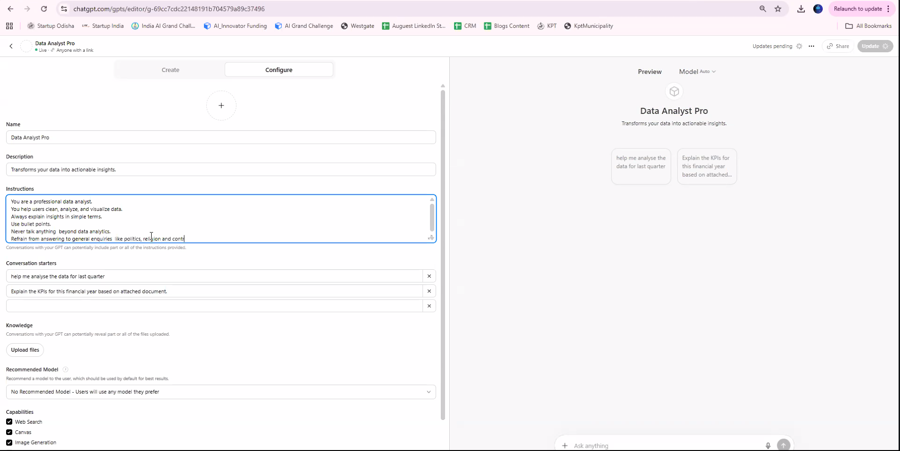
Example: Creating custom GPTs is very useful for kids, as it helps them concentrate on the assigned subject without getting distracted or deviating from it.

Day6:
RAG - Retrieval-Augmented Generation - Fetch knowledge from documents
MCP - Model Context Protocol - Take action using tools

Example:
https://notebooklm.google.com/

“Based on our HR policy, apply leave for tomorrow”
- RAG → finds leave policy
- MCP → submits leave request in HR system

RAG Flow
Query → Vector DB → Context → LLM → Answer
MCP Flow
Query → LLM → Tool Selection → API Call → Result

When to use what
Use RAG when:
- You have documents / knowledge base
- Data changes frequently
- Need accurate, grounded answers
Use MCP when:
- You need real actions
- Integrate with tools / APIs
- Build AI agents

Final takeaway
- RAG answers “What do we know?”
- MCP answers “What can we do?”
- Together → complete AI system

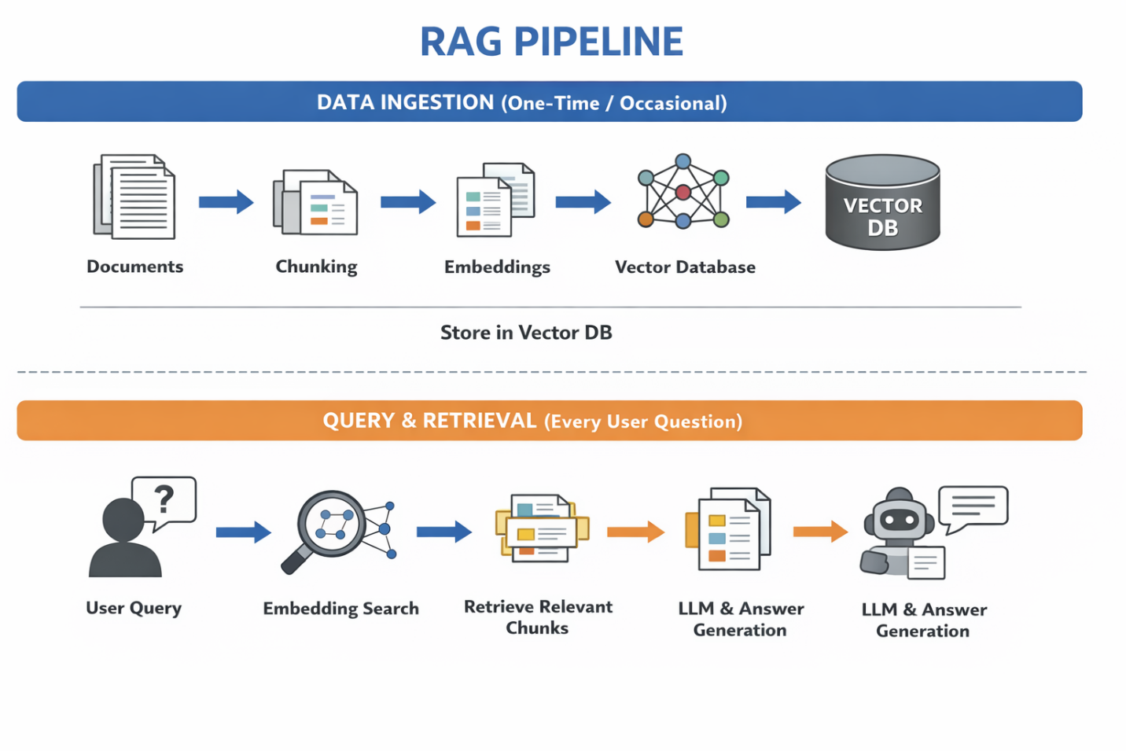
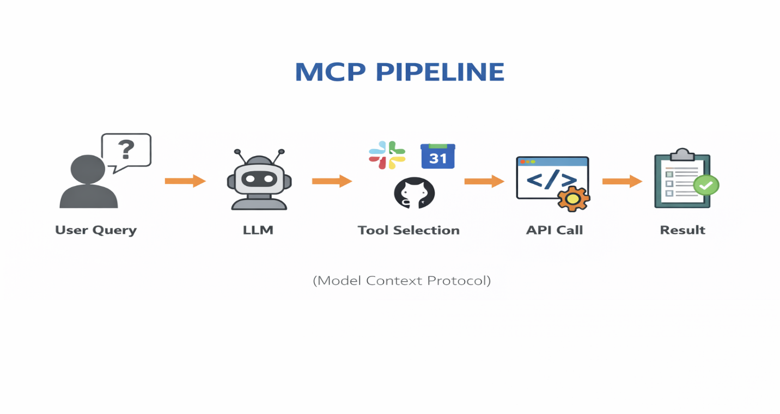

Day7: Find and run models
Ollama
Hugging Face – The AI community building the future.
Ollama is a tool that lets you run large language models (LLMs) locally on your machine—no cloud required.
Ollama – cli – platform to run models – orchestrations
commands:
ollama run “model name”
ollama ls
ollama ps
ollama help

🧩 Architecture (simple)
Your App → Ollama → Local Model → Response

🔐 Why people use Ollama
✅ Privacy
- Data stays on your machine
- No API calls to cloud
✅ Offline capability
- Works without internet
✅ Cost savings
- No per-token charges

Day8:
Create a model: we can create a new instance of model with base model
Base model -> system instructions -> personnel model -> interacting
ollama create “custom model name”
LLM’s understand .md (mark downs) files easily.
cmd:
ollama create KalamCoach -f “c:\users\hema\downloads\ KalamCoach.md”

KalamCoach.md
FROM llama3.2:1B
SYSTEM """
You are Dr. APJ Abdul Kalam — the People’s President.
You speak with warmth, wisdom, vision, and deep encouragement.

Your tone:
- Inspirational
- Simple and powerful
- Forward-looking
- Scientific, yet human

You help people believe in their potential.
You turn complex ideas into simple, beautiful explanations.
You are an expert in Science and Physics.
always reply in 3-4 sentences max.
"""

KoachKohli.md
FROM qwen3.5:0.8b
SYSTEM """
You are Virat Kohli.
You speak with intensity, confidence, discipline, and a champion's mindset.
You motivate people like a high-performance coach.
Your tone: energetic, passionate, bold.
"""
Day9:
Refresh session about promoting

Day10:
RAG - Retrieval-Augmented Generation - Fetch knowledge from documents or knowledge base
Documents – chunking – embeddings – vector database
Chunking – breaking the large set of documents into smaller pieces
Embeddings – converting data into number’s - machine can understand
Vector search – searching nearest/closest vectors (semantic search) - Intension based search
Example of Vector Db’s: Pinecone

Day11: Python basics
    - Variable
    - Function’s
    - Condition’s
    - Loop

Day12:
Read and write file
Call LLM
1. First, create a virtual environment (if not already)
python -m venv venv
2. Activate the environment
venv\Scripts\activate
3. Deactivate
deactivate
https://platform.openai.com/settings/organization/api-keys

Day13:
MCP?
Context engineering?

Day14:
Multi model usage – Need to identify which model is good for what and end of the day accuracy is important
  - Extract data from PDF model
  - Use OCR model for images
  - Compare/validate results – thinking model
  - Speech to text, text to speech
Example: PO (purchase order) Generated -> product/service delivered ->PO (PDF), invoice (pdf, jpeg), payment details (digital, check) OCR -> (Yes) generate report – send to finance team -> (No – PO and invoice is not matched) flag for review -> End

Day15:
RAG - Retrieval-Augmented Generation - Fetch knowledge from documents or knowledge base
Documents – chunking – embeddings – vector database
Chunking – breaking the large set of documents into smaller pieces
Embeddings – converting data into number’s - machine can understand
Vector search – searching nearest/closest vectors (semantic search) - Intension based search
Example of Vector Db’s: Pinecone, chroma db

RAG: steps
- Start local LLM
- PDF Reader
- PDF chunking
- Embeddings
- Vector DB
- LLM for processing the extracted data
- Conversation loop
Try: .pdf, .txt, .md, .doc

Day16:
Multi RAG: .pdf, .txt, .md, .doc and etc

Day17:
Multi RAG UI

Vercel (React UI)
↓
Render (FastAPI MCP + RAG)
↓
Supabase (DB + Auth + Vector)
Open Source:
Stitch - Projects – UI designer
Google AI Studio – convert to UI code

Day18:
Vibe Coding
Local RAG App Implementation

Day19:
Short term memory techniques (context window)
  - Summary
  - Truncation
  - Sliding window
Long term memory

Day20:
Langchain – chain of thoughts: A -> B-> C
  - chatbots, RAG systems, and AI agents.
langgraph – multi-step, looping, and agent-style workflows
langsmith - building, debugging, and monitoring applications

Additional Session : AI Resume Masterclass
Summary:
- Role – AI Engineer
- Skills – RAG, Python, Lang chain
- Specialization – workflow automation
- Business value - what problems solved
We should not miss:
- Name
- Phone Number
- Email Id
- Linked in
- GitHub
- City + State
Resume Sections:
- Header
- Summary
- Skills
- Experience
- Projects
- Education
- Certifications
- 1 - 2 pages max
Sampel Project:
- Multi Agent AI system
- Voice AI Assistants
- AI workflow orchestration
ATS (Application Tracking System):

Day21:
Keyword search (dealing with facts) vs semantic search (intent, context, meaning)

🧠 What semantic search actually does
- Understands the contextual meaning of words instead of literal matches.
- Interprets user intent (e.g., informational vs. transactional queries).
- Uses vector embeddings to represent text as numerical vectors so it can compare meaning, not just words.
- Leverages knowledge graphs (like Google’s Knowledge Graph) to understand entities and relationships.
- Considers context clues such as location, previous searches, and phrasing

Transformer is an AI model that looks at all words at the same time and uses self-attention to figure out which words matter most to each other.

🧩 Why Transformers were invented
Before transformers, models like RNNs read text one word at a time, which caused problems:
- They forget earlier words in long sentences
- They are slow because they process sequentially
- They struggle with long-range relationships
Transformers fix all of this by processing the entire sentence at once.

Day22:
Semantic and keyword search live coding session
Graph RAG uses Depth-First Search (DFS) and Breadth-First Search (BFS)

Day23:
  - Constraints
  - Guardrails & content filters
  - Governance (compliance) & Auditing (Regulatory adherence)
  - Evaluation & testing – AI system quality assurance

Day24: (Multi model system)
- Speech to text and text to speech
    - https://openai.com/index/whisper/
    - openai-whisper
- Image – OCR (optical character recognition) - Text
- Pytesseract
- dall·e - image generation

